Filling the Holiday Gap 2019
Guidance for Projects
April 2019

Introduction
Cornwall Council’s Wellbeing and Public Health Team are seeking applications for the 2019 Filling the Holiday Gap grant scheme to provide free enrichment activities and healthy food for disadvantaged children and families during the school summer holidays.
The 2019 grant follows on from the pilot project last year and is focused on how projects can alleviate the financial pressure on household incomes by providing enrichment sessions that include an activity and a nutritious meal. The scheme recognises that flexibility is important and innovation is encouraged; applications that involve partnership working are welcome as are projects that can engage the community or demonstrate wider benefits to individual or family wellbeing.
The maximum any single organisation can apply for is £3500 (there is no minimum) and applications are expected to provide excellent value for money. Projects should be geographically located in one of the 6 localities shown on the map below. Consideration will be given to projects that cross over these locality boundaries where a need is highlighted.
The Council is seeking proposals from interested community groups, voluntary and charitable organisations that can deliver a series of activity based sessions during the school summer holiday period of the 25th July to the 4th September 2019 that provide a free nutritionally balanced meal and an activity for children.
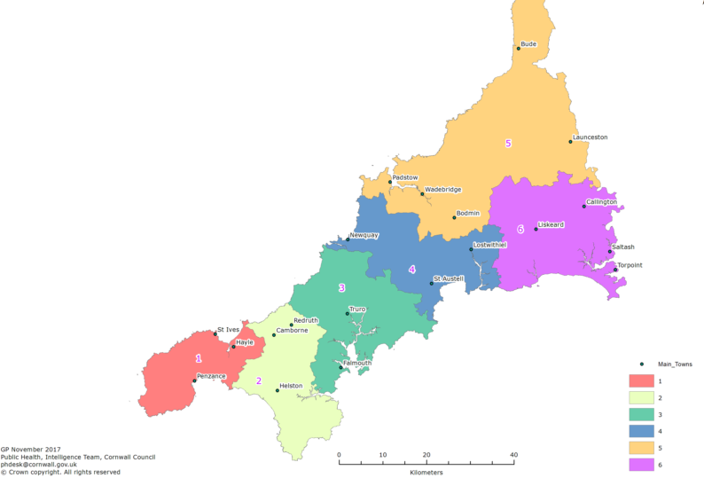

A grant of up to £3500 is available. The minimum standards that we expect for 2019 providers are:
  - Food: clubs must provide at least one meal a day (breakfast, lunch or tea) and all food provided at the club (including snacks) must meet the school food standards.
  - Nutritional education: clubs must include an element of nutritional education each day aimed at improving children’s knowledge and awareness of healthy eating. These do not need to be formal learning activities and could for example include activities such as getting children involved in food preparation and cooking; growing fruit and vegetables, and taste tests.
  - Enriching activities: clubs must provide fun and enriching activities that provide children with opportunities to develop new skills or knowledge, to consolidate existing skills and knowledge, or to try out new experiences. This could include physical activities such as football, table tennis, cricket etc.; creative activities such as putting on a play, junk modelling, drumming workshops; or experiences such as a nature walk, visiting a city farm etc. Bidders should set out how they can deliver a rich and varied mix of fun and enriching activities which are age-appropriate.
  - Physical activities: clubs must provide activities which meet the Physical Activity guidelines on a daily basis.

Completing the form
The application form is your opportunity to describe the aims of your project and explain how the project will operate but we welcome a discussion with any applicant to help support you in this process.
Please complete all sections of the form and use the guidance to help you. If you are unsure about any sections or would like further information please contact Matt Sharp at msharp@cornwall.gov.uk.

General conditions
Groups are considered eligible to apply if:
- They are Not For Profit community or voluntary groups or organisations (with a governing document and bank account with at least two signatories)
- Schools or members of the whole school community.
- Informal networks of community members if you are supported by a constituted group with a bank account that can hold the funds on your behalf.

Each project will be expected to monitor their delivery; a description of how you intend to do this should be included in the application. The minimum information required will be:
- Postcode of residence
- Age
- Date of attendance.
The project should not duplicate existing services commissioned by Cornwall Council.
The project should deliver its services in areas where there is a higher demand for free school meals.
Key Dates:
- Applications invited from 24th April 2019
- Application deadline 27th May 2019
- Confirmation of successful bids
and funding allocation transferred 12th June 2019
- Projects begin from 25th July 2019
- Projects end 4th September 2019
- Evaluation reports provided by 8th October 2019

Cornwall Council, Filling the Holiday Gap scheme 2019
Application for Funding
About Your Group

Name of Group:
Name of contact and job title:
Email address:

Telephone number:
Postal Address:

About the Project

Project Title:

Project overview:
Please describe your proposed project and its key principles; include what locality/area the project will cover, who you aim to engage, how many children/families will benefit and how it will meet local needs.

Project delivery:
Please describe how you will deliver each of the minimum standards as set out in the application guidance above.

Project Impact:
Describe how you will demonstrate that the project has been successful and how you will monitor the impact of your approach.

What are your proposed dates for delivery?
If it is not possible to give dates please provide the number of sessions or days of the week. Projects must be delivered in the 2019 school summer holidays.

Budget Breakdown:
How much funding are you applying for? (maximum £3,500)
What will you spend the funding on? Your project costs must be clearly worked out.
We expect costs are minimised and you must not make any profit.

Total Amount Requested: £

Would this project normally be funded by another funding stream or organisation?
Will you be combining funding to deliver this project?
If yes, please state which funding stream or what organisation.

Added Value:
Are there additional elements of your project you can tell us about that do not have a cost attached to them, this may be things like linking with other projects that support families, improve other aspects of health and wellbeing, reducing food waste, supporting debt management etc.

Are there any aspects you think Cornwall Council may be able to support the
project with?
This may include parking, assisting with activity provision or free venue hire.

Are there any aspects of the project that will continue or be sustained after the funding has ended?

I declare that the information supplied in the Filling the Holiday Gap application is true.

I agree that, if this application is successful, any grant money received will be used for the purposes described in this application and in accordance with the terms and conditions listed below. I confirm that I am duly authorised and empowered to confirm this on behalf of the applicant group.

Signature: Date:

Name (Please Print):

Filling the Holiday Gap Grant Scheme - Terms and Conditions

- Grants awarded under the scheme must only be used to support the expenditure identified in the application, as approved, and for no other purpose.
- The grant should usually be spent within six months of being awarded. If it is likely that there will be a delay, the applicant must notify the Public Health Team.
- The applicant should retain all receipts and proof of expenditure for the purposes of possible audit at a later date. Spot checks may be made.
- The applicant must not use the grant for any unlawful activities, the promotion of political and/or religious activity or activities that are discriminatory on the grounds of religion, race, sex, sexual preference, age or disability.
- The applicant must not use the grant to pursue any activity required to meet statutory regulations.
- Projects should not be for private profit.
- If appropriate, the applicant must have insurance for any activity which the grant will be wholly or partly funding. This includes public liability cover at any community event.
- Recognition of Cornwall Council financial support must be included on any promotional materials.
- The applicant will be required to participate in any publicity deemed appropriate by Cornwall Council associated with the offer of funding.

Privacy Notice: This information is being collected by Cornwall Council. The Chief Executive is the Council’s Data Controller. Any information provided may be retained on computer or in manual files in accordance with the Council’s policy for the retention of information. This information will be used for processing your grant application. It may also be used for related council purposes, including for regulatory functions and investigating fraud. It will not be disclosed to any third party except where the council specifically contracts for data processing support. The information may be used for statistical or research purposes, which will be de-personalised where appropriate.
The following documents will be required should your application be successful. Cornwall Council may be able to provide support to achieve any of the documents should this be required.
Your group’s rules or constitution
Your annual accounts or statement of income and expenditure for the last 12 months
Evidence of DBS clearance(s) for staff
Evidence of Public Liability Insurance
Evidence of food hygiene certification if relevant
Evidence of trained first aider(s)
Evidence of fire risk assessment
Evidence of risk assessments for children’s activities
Evidence of sun safety risk assessment (if outdoor activity takes place)

Completed forms should be returned to.
Email: matt.sharp@cornwall.gov.uk

Or post to:

Matt Sharp
Wellbeing and Public Health
New county Hall
Floor 1 East
Truro
TR1 3AY

If you would like this information
in another format please contact:
Cornwall Council, County Hall
Treyew Road, Truro TR1 3AY
Email: comments@cornwall.gov.uk
Telephone: 0300 1234 100
www.cornwall.gov.uk

The current guidelines state that children should engage in moderate to vigorous intensity physical activity for at least 60 minutes a day. We understand that these guidelines will be revised in 2019. We will discuss any necessary changes to the minimum standards resulting from this with successful bidders.

