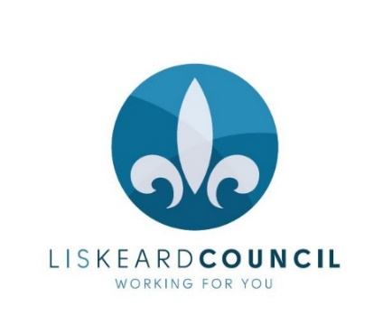

LISKEARD TOWN COUNCIL
COMMUNITY CHAMPION AWARD 2023 NOMINATION FORM

These awards are for those who have made a positive difference to life in Liskeard. They recognise individuals, local businesses and groups, and can be made for a wide range of voluntary endeavours including:
- Actions which bring the community together
- Positive environmental impact
- Community service
- Helping others or a charity and acts of neighbourliness
- Someone who has battled against the odds for something they believe in
- Gaining exceptional recognition for Liskeard

Who is not eligible: Liskeard Town Council staff and councillors, honoured burgesses, and anybody who has received a Community Champion Award in the last 3 years

Award category  (please tick) | Outstanding Individual  Outstanding Group/Business  Outstanding Young Person  (Nominees must be aged 18 or under)
Who would you like to nominate?

Nominee’s contact details:  Address | Postcode:
Telephone number

Email

Your name

Your contact details:  Address | Postcode:
Telephone number

Email

Why do they deserve the award?
(continue on a separate sheet if needed)

All data is collected for the purposes of Community Champion Awards in 2023 only and will be held confidentially by Liskeard Town Council and not disclosed to any other party without the subsequent consent of the proposer or nominated person. Nominations that do not succeed will be destroyed. Successful nominations will be retained for record purposes.

Applications will be assessed by a selection panel and successful nominations will receive an invitation to attend the Community Champion Awards ceremony at the Annual Town Meeting on Thursday 16 March at 7pm to collect their awards. Details of selected candidates will not be published until the ceremony.

Signed:

Date

Please return to Liskeard Town Council, 3 – 5 West Street, Liskeard PL14 6BW or email office1@liskeard.gov.uk by the closing date of 9am on Monday 20 February 2023

