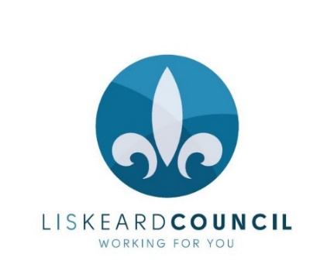

LISKEARD TOWN COUNCIL
COMMUNITY CHAMPION AWARD SCHEME NOMINATION FORM

These awards are for those who have made a positive difference to life in Liskeard. They recognise individuals and groups, and can be made for a wide range of endeavours including:
- Actions which bring the community together
- Environmental or community service
- Helping others or a charity in their own time
- Acts of neighbourliness
- Someone who has battled against the odds for something they believe in
- Gaining exceptional recognition for Liskeard

Award category  (please tick) | Outstanding Individual  Outstanding Group  Outstanding Young Person  (Nominees must be aged 18 or under)
Who would you like to nominate?

Nominee’s contact details:  Address | Postcode:
Telephone number

Email

Your name

Your contact details:  Address | Postcode:
Telephone number

Email

Why do they deserve the Award?
(please clearly explain in no more than 300 words)

Please ensure you have the nominee’s permission to share their data with the Town Council. We will use this to review and process the application, make further enquiries or clarify information provided, and to send invitations for the Award ceremony.

Signed:

Date

Please return to Liskeard Town Council, 3 – 5 West Street, Liskeard PL14 6BW or email office1@liskeard.gov.uk by the closing date of noon on Friday 5 April 2019

Applications will be assessed by a selection panel on Monday 8 April. Successful nominations will receive an invitation to attend the Community Champion Awards ceremony at the Annual Town Meeting on Thursday 25 April at 7pm to collect their awards. Details of selected candidates will not be published until the ceremony. Awardees will be asked whether they are happy for publicity.

